Document Guidance
This document is intended as the summary template for Case Studies contributed as evaluations and supporting information for the PSDI Library of Use Cases.
The 3-page summary is intended to convey the important elements of the Use Case that can be used to feed into the requirements for the design of the PSDI.

Please note that this document should ideally follow our branding guidelines based around the fonts and colour schemes included in the document. If these do not work properly on your computer either contact Nicola Knight on n.knight@soton.ac.uk or use a consistent scheme in your document (utilising in built font styles) that we can adjust manually.
Header font: Open Sans Condensed
Body font: Lato

Colours: if these colour boxes match up the document has applied the colour theme.

#ff9e18

#3d7cc9

#002169
#011e41

#9d90a0
#e5e1e6
#bbbbbb
#5aa2ae

Please delete this page and the guidance text in the document once complete

Title of Use Case

Authors and affiliations

The overall aim of the Case Study
  - Up to 1 page using the following sub-headings (please delete guidance text once covered)

Area of Physical Sciences covered
Areas directly covered by your use case. Please list research areas that your community and colleagues would readily understand but also try to relate them to the EPSRC Physical Sciences Research Areas as per https://gow.epsrc.ukri.org/NGBOListThemeDrillDown.aspx?CapabilityTheme=Physical%20Sciences&ItemId=Physical%20Sciences&_gl=1*el2v6t*_ga*OTM4MDQ3NzczLjE2NDQ4NTQzNDE.*_ga_HPSM59M7J4*MTY0NDg1NDM4My4xLjEuMTY0NDg1NDQxOS4w.

Related PS research areas
Other Physical Sciences areas that the Use Case (or parts of it) would be applicable to. Please, again, relate commonly used research areas to the EPSRC categories as above if possible.

Applicability to the Research Data Lifecycle
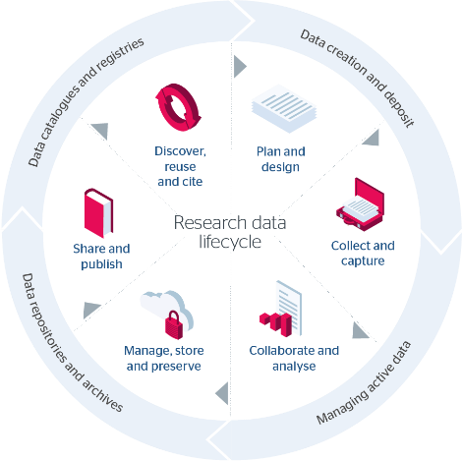
The parts of the research data lifecycle this Use Case addresses/supports – we are using the Jisc definition at: https://www.jisc.ac.uk/guides/rdm-toolkit
Plan & Design
Collect & Capture
Collaborate & Analyse
Manage, Store & Preserve
Share & Publish
Discover, Reuse & Cite

Use Case Description
A brief description highlighting the main areas of focus and activity of the Use Case

  - Section 2 - up to 2 pages

Main Content
More detailed description of the Use Case activities and areas of need.
Links to further information e.g. associated reports

Outcomes and Recommendations
For each outcome please include at least the following:
- Recommendations
- Benefits of making these changes
- What pieces of ‘PSDI infrastructure’ would enable/empower this work in the future?
Infrastructure doesn’t only mean hardware/software but also encompasses people / training.
When developing recommendations, you should consider the following:
- What do you clearly need from PSDI
- What would be nice from PSDI
- What is needed but may be beyond the scope of PSDI

